# AIAC ASSIGNMENT 8.2:

K.CHANDRIKAA

2403A51227

B-10

TASK 1:

Task Description#1  
Use AI to generate test cases for a function is_prime(n) and then implement the  
function

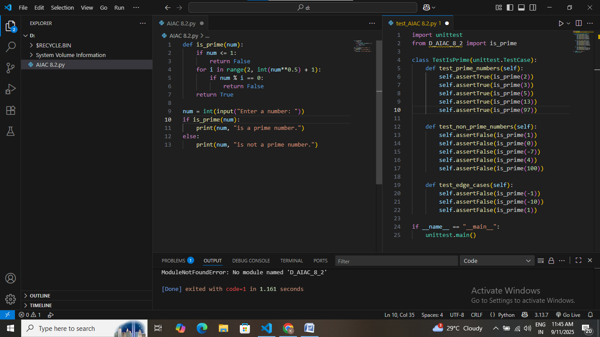

Task Description#2 (Loops)  
• Ask AI to generate test cases for celsius_to_fahrenheit(c) and fahrenheit_to_celsius(f).

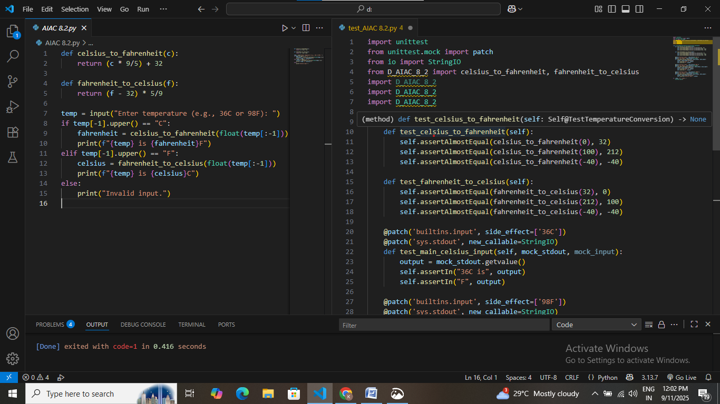

Task Description#3  
Use AI to write test cases for a function count_words(text) that returns the number of  
words in a sentence

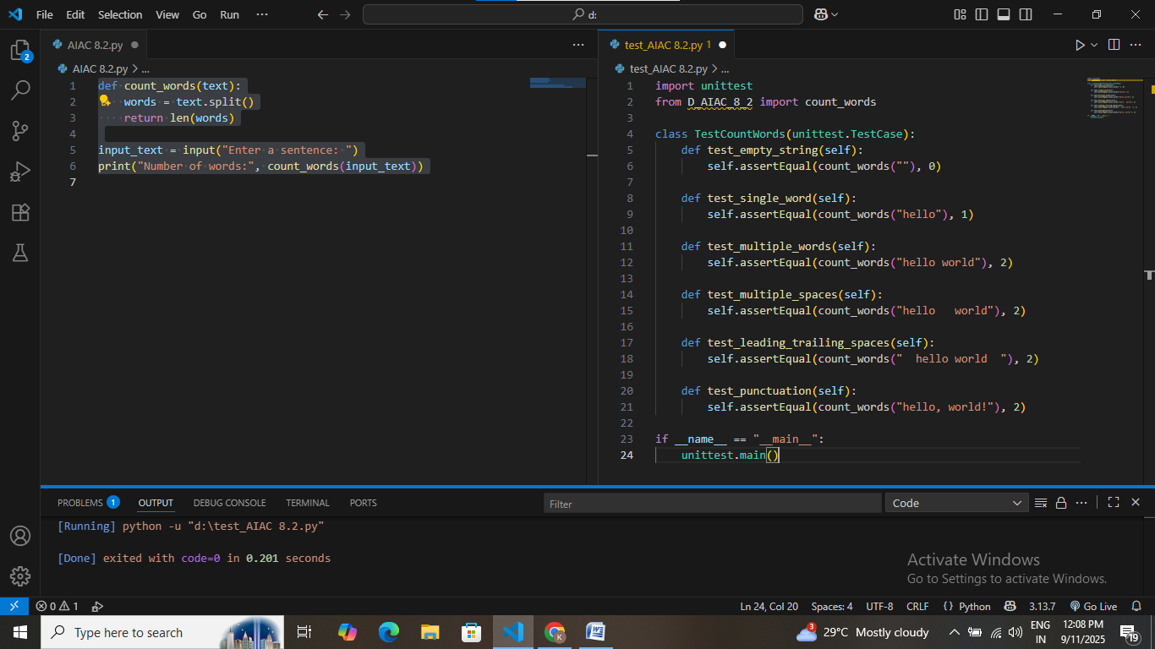

Task Description#4  
• Generate test cases for a BankAccount class with:  
Methods:  
deposit(amount)  
withdraw(amount)  
check_balance()

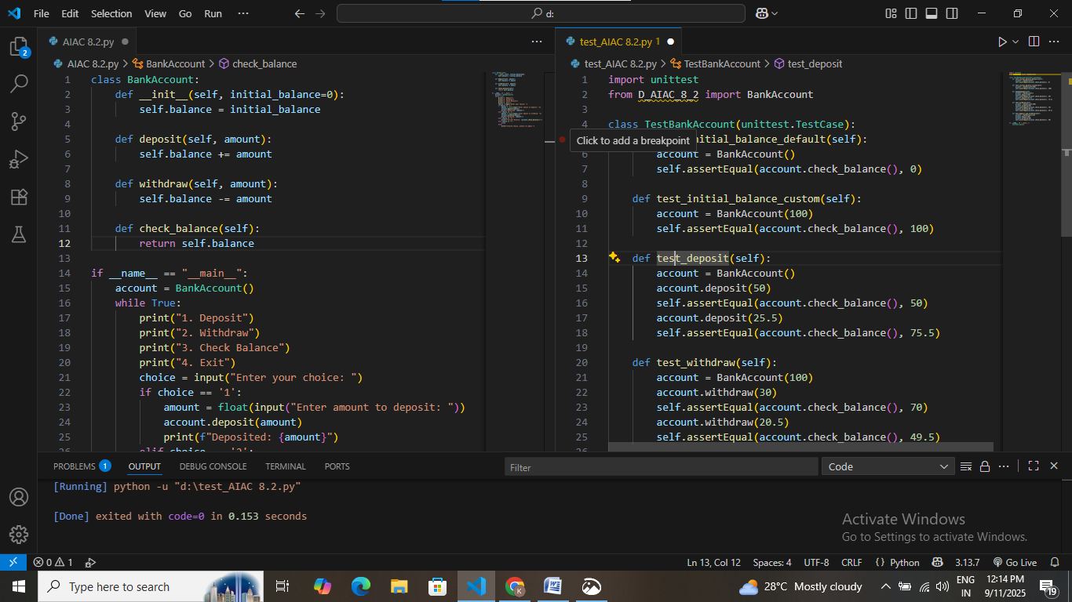

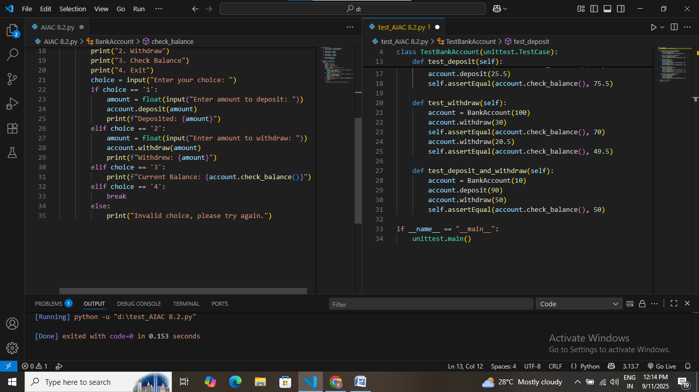

Task Description#5  
Generate test cases for is_number_palindrome(num), which checks if an integer reads  
the same backward

